***PF LAB 5:***

**Task 5:**

*#include <stdio.h>*

*int main() {*

*int course;*

*char grade;*

*printf("Enter course number (1, 2, or 3): ");*

*scanf("%d", &course);*

*switch (course) {*

*case 1:*

*case 2:*

*case 3:*

*printf("Enter grade (A, B, C, D, F): ");*

*scanf(" %c", &grade);*

*switch (grade) {*

*case 'A': printf("Excellent\n"); break;*

*case 'B': printf("Good\n"); break;*

*case 'C': printf("Average\n"); break;*

*case 'D': printf("Poor performance in course %d.\n"); break;*

*case 'F': printf("Fail\n"); break;*

*default: printf("Invalid grade entered.\n"); break;*

*}*

*break;*

*default:*

*printf("Invalid course number.\n");*

*break;*

*}*

*return 0;*

*}*

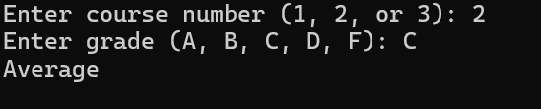

**Task 6:**

*#include <stdio.h>*

*int main() {*

*int x, y, z, max;*

*printf("Enter three numbers: ");*

*scanf("%d %d %d", &x, &y, &z);*

*max = (x > y) ? ((x > z) ? x : z) : ((y > z) ? y : z);*

*printf("Largest number = %d\n", max);*

*return 0; }*

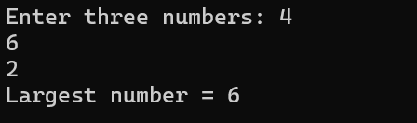

**Task 7:**

*#include <stdio.h>*

*int main() {*

*int a, b;*

*printf("Enter two integers: ");*

*scanf("%d %d", &a, &b);*

*printf("Sum = %d\n", a + b);*

*printf("Difference = %d\n", a - b);*

*printf("Product = %d\n", a * b);*

*printf("Quotient = %d\n", a / b);*

*printf("Remainder = %d\n", a % b);*

*return 0;*

*}*

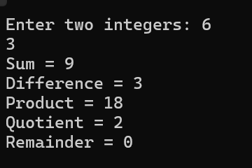

**Task 8:**

*#include <stdio.h>*

*int main() {*

*int a, b,result;*

*printf("Enter two integers: ");*

*scanf("%d %d", &a, &b);*

*result = (a == b);*

*printf("%d",result);*

*result = (a > b);*

*printf("%d",result);*

*result = (a < b);*

*printf("%d",result);*

*result = (a != b);*

*printf("%d",result);*

*result = (a >= b);*

*printf("%d",result);*

*result = (a <= b);*

*printf("%d",result);*

*return 0;*

*}*

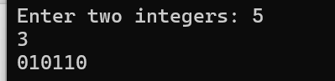

**Task 9:**

*#include <stdio.h>*

*int main() {*

*int a, b;*

*printf("Enter two integers: ");*

*scanf("%d %d", &a, &b);*

*printf("a & b = %d\n", a & b);*

*printf("a | b = %d\n", a | b);*

*printf("a ^ b = %d\n", a ^ b);*

*printf("~a = %d\n", ~a);*

*printf("a << 1 = %d\n", a << 1);*

*printf("a >> 1 = %d\n", a >> 1);*

*return 0;*

*}*

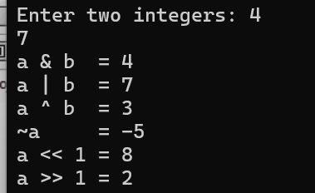

**Task 10:**

*#include <stdio.h>*

*int main() {*

*int x, y, z;*

*printf("Enter three numbers: ");*

*scanf("%d %d %d", &x, &y, &z);*

*if (x > y) {*

*if (x > z)*

*printf("Largest = %d\n", x);*

*else*

*printf("Largest = %d\n", z);*

*}*

*else {*

*if (y > z)*

*printf("Largest = %d\n", y);*

*else*

*printf("Largest = %d\n", z);*

*}*

*return 0;*

*}*

